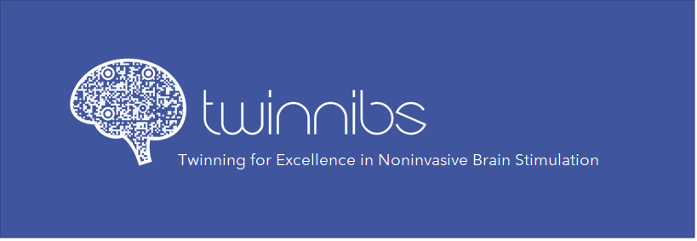
Bootcamp application
ESR application form (explanations in blue are there to help you fill in the application and should be deleted before submitting the form)

ESR information
Name Surname
Country of residence | Write here your current country of residence; if you will change residence in 2023-2024 you can write more than one country
Language(s) | e.g., Italian (native), English (working proficiency), German (basic communication/understanding)
Gender | Male / Female / Non-binary
Study stage | Year 1/2 /3/4 of First degree /Bachelors/ Master/ PhD
Study institution | Write the full name of the program, institution, university, city, country
Degree(s) | If you already have a degree, write here the obtained title and the issuing institution, university, city, country
Email | The address you write here will serve as primary means to contact you
Are you currently employed/on a stipend at scientific institution | No/Yes, I am under contract as ____________ (specify position), at __________ (name of the institution) for period _________ (e.g. 2023-2025; until May 2024; permanent)
What are your areas of interest? (up to 100 words) | Write a short statement about your main areas of interest in terms of scientific discipline/filed (e.g. neurophysiology, cognitive science, data science, psychology, etc.), and specific interests within that field.  Write here in which NIBS techniques, you are interested (e.g. TMS, tDCS, etc) as well as which complementary techniques you find appealing (e.g. neurophysiological measures, EEG, MRI, surveys, cognitive tasks, etc)
What is your motivation to apply for the TWINNIBS bootcamp? (up to 200 words) | Write a short paragraph about what motivates you to apply focusing on what you see as benefits and how that will help you advance your knowledge and carrier.
What is your relevant prior experience? (up to 100 words) | Focus on what you know and what you will bring to the project

Topic selection
Which topic(s) would you like join? | Select one or more of the following (delete non-selected options):  - Systematic review: Sources of variability in studies using non-invasive brain stimulation to induce corticomotor plasticity (A. Faghani Jadidi)  - Transcranial static magnetic stimulation (tSMS): registered report on replication of the effects of neuronavigated tSMS on corticospinal excitability (L. Cattaneo)  - Pseudo-online tracking of EEG oscillations during sensory discrimination tasks, for closed-loop NIBS applications (A. Savić)  - Transcranial electrical stimulation effects on 40Hz auditory steady-state response (I. Griskova Bulanova)  - Non-invasive brain stimulation and eating behaviours: State of the art and in-depth exploration of outcome measures (M. Zeković)
Why do you prefer this topic(s)? (up to 100 words) | Specify what do you like about the topic and why it stood out for you.
Type of work would you like to do? | Select as many as you wish (delete non-selected options):  - Reading and extracting data/information from literature  - Designing a study/experiment  - Developing tasks/surveys  - Witing code (Matlab/Phyton)  - Collecting data/conducting experiment  - Contacting/debriefing participants  - Managing/sorting/curating data  - Creating data visualizations/graphs/illustrations  - Analysing neurophysiological data (EEG)  - Analysing neuroanatomical data  - Statistical analysis  - Witing manuscript  - Presenting at conferences  - Submitting manuscript to the journal  - Revising manuscript and responding to reviews  - Writing summaries for general public  - Preparing materials and data for sharing (Open Science)
Do you have prior knowledge/experience with NIBS techniques? | Select as many as you wish (delete non-selected options):  - I have no prior knowledge, but I would like to learn  - I have basic understanding of what NIBS is, but no more than that  - I have read the literature, but I don’t have practical experience  - I have practical experience with ___________(specify the technique e.g., TMS, tDCS)  - I work with NIBS for my project/thesis  - I have published paper in which NIBS is used (provide a reference here)
What is your prior experience with data collection? | Select as many as you wish (delete non-selected options):  - I have no first-hand experience with data collection  - I have collected survey/questionnaire type data  - I have collected data in interviews or in-person standardized assessment  - I have collected data in neurophysiological studies (specify the technique(s) here)  - I have done cognitive assessment (please specify: )  - I have conducted data collection in healthy participants  - I have conducted data collection in clinical population (please specify: )  - I have conducted data in sensitive/vulnerable populations (e.g. children, elderly, people with disabilities, minorities) (please specify:)
Do you have previous experience with literature review? | Select as many as you wish (delete non-selected options):  - I have no prior experience with reading scientific papers, only textbooks  - I have done literature reviews during my studies (for essays, seminars)  - I have done literature review for withing introduction to my thesis/course work  - I have done literature review for empirical manuscript that is submitted/published (provide a reference here)  - I have done literature review and wrote a review article that is submitted/published (provide a reference here)  - I know what PRISMA is, but I have not used it yet  - I have done systematic review and coding of the papers but never in a form of an article  - I have done systematic review following PIRSMA or similar guidelines that is submitted/published (provide a reference here)
Do you have previous experience with statistical analysis? | You can answer No, or Yes. If you answer Yes, please list software you have been working in, and type of analysis you have done.
Do you have previous experience with signal processing and EEG analysis? | You can answer No, or Yes. If you answer Yes, please list software you have been working in, and type of analysis you have done.

Availability and engagement
Time requirements | In respect to your selected topic, please wite here: I will be available to work on the project for X days a month during the X months. Use this space to specify any specific time constrains you have e.g. I will be available full time during May-June but will not be available in August 2023. If the topic you selected specifies certain among of time to be spent in the lab (e.g., 2 weeks for data collection), please write here your availability to do that.
Physical location | Specify the location/travel availability. For example, you can write I would like to work only remotely, or I would like to work remotely, but I am also available to spend 2 weeks in _____ (name of the city relevant for the topic you selected) or I share the city of residence with the mentor so I will be available for both physical and remote work.
Special requirements | If there are any special requirements/limitations to be involved in the project, please list them here

